Brazilian E-Commerce Data Analysis using SQL
Objective:
To analyze customer behavior, order trends, and revenue patterns using SQL queries on the Olist dataset.
Tools Used:
- PostgreSQL (pgAdmin 4)
- SQL (Aggregation, JOIN, HAVING, CTE, Window Functions)

Dataset: Brazilian E-Commerce Public Dataset by Olist

Learning Outcome:

• Data cleaning and type casting

• Writing optimized SQL queries

• Understanding GROUP BY, HAVING

• Using JOIN to combine tables

• Applying CTE and Window Functions

- Total Orders

Explanation: Counts total rows in orders table.

SELECT COUNT(*) AS total_orders
FROM olist_orders;
Output:
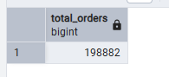

- Orders per Status
Explanation: Groups orders by status and counts them.

SELECT order_status, COUNT(*) AS total
FROM olist_orders
GROUP BY order_status;

OUTPUT:
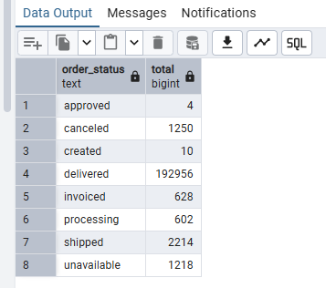

- Orders per Day
Explanation: Extracts date and counts daily orders.
SELECT
DATE(order_purchase_timestamp::TIMESTAMP) AS order_date,
COUNT(*) AS total_orders
FROM olist_orders
GROUP BY order_date
ORDER BY order_date;
OUTPUT:
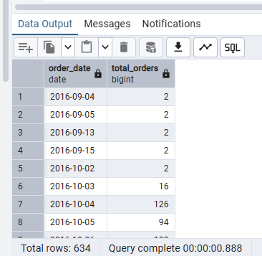

- Total Revenue

Explanation: Adds all payment values (after cleaning text data).

SELECT SUM(payment_value::NUMERIC) AS total_revenue
FROM olist_order_payments
WHERE payment_value ~ '^[0-9]+(\.[0-9]+)?$';

OUTPUT:
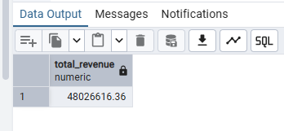

- Revenue by Payment Type
Explanation: Shows revenue contribution by each payment method.

SELECT payment_type,
SUM(payment_value::NUMERIC) AS total
FROM olist_order_payments
GROUP BY payment_type;
OUTPUT:
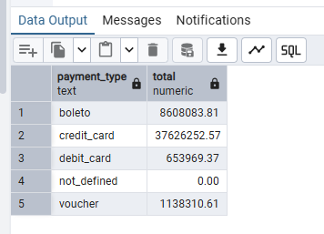

- Customers per State

Explanation:Counts customers in each state.

SELECT customer_state, COUNT(*) AS total
FROM olist_customers
GROUP BY customer_state
ORDER BY total DESC;
OUTPUT:
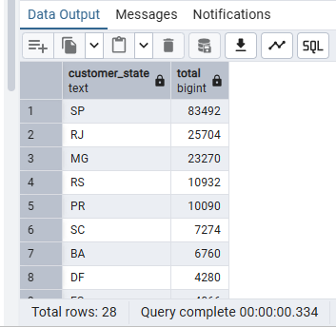

- Top 5 States by Orders (JOIN)

Explanation: Combines orders + customers to find top states.

SELECT
c.customer_state,
COUNT(*) AS total_orders
FROM olist_orders o
JOIN olist_customers c
ON o.customer_id = c.customer_id
GROUP BY c.customer_state
ORDER BY total_orders DESC
LIMIT 5;
OUTPUT:
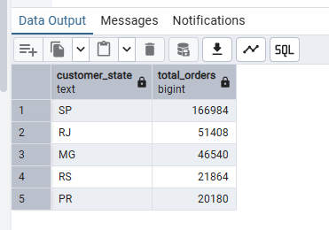

- Payment Types with High Revenue (HAVING)

Explanation: Filters only high-revenue payment types.

SELECT

payment_type,

SUM(payment_value::NUMERIC) AS total

FROM olist_order_payments

GROUP BY payment_type

HAVING SUM(payment_value::NUMERIC) > 100000;

OUTPUT:

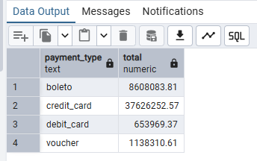

- Top 3 Highest Payments (WINDOW)

Explanation: Ranks payments and returns top 3.

SELECT *
FROM (
SELECT
order_id,
payment_value::NUMERIC,
ROW_NUMBER() OVER (
ORDER BY payment_value::NUMERIC DESC
) AS rn
FROM olist_order_payments
) t
WHERE rn <= 3;
OUTPUT:
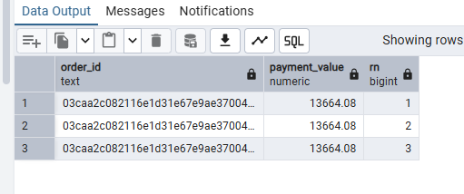
10. Top 2 Customers per State (WINDOW)
Explanation: Ranks customers within each state.

SELECT *
FROM (
SELECT
customer_unique_id,
customer_state,
ROW_NUMBER() OVER (
PARTITION BY customer_state
ORDER BY customer_unique_id
) AS rn
FROM olist_customers
) t
WHERE rn <= 2;

OUTPUT:
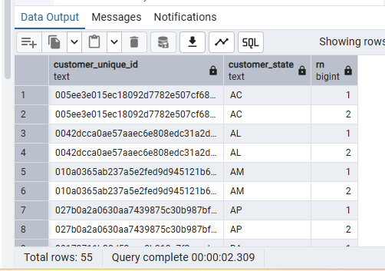

- Order Revenue (Basic CTE)
Explanation: Creates a temporary table of revenue per order.

WITH order_revenue AS (
SELECT
order_id,
SUM(payment_value::NUMERIC) AS revenue
FROM olist_order_payments
GROUP BY order_id
)
SELECT *
FROM order_revenue;
OUTPUT:
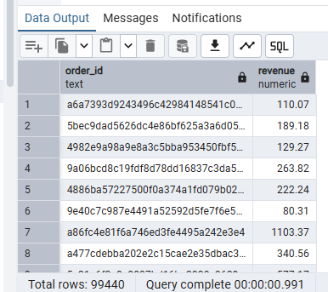

12. High Value Orders
Explanation: Filters orders with high revenue.

WITH order_revenue AS (
SELECT
order_id,
SUM(payment_value::NUMERIC) AS revenue
FROM olist_order_payments
GROUP BY order_id
)
SELECT *
FROM order_revenue
WHERE revenue > 1000;
OUTPUT:

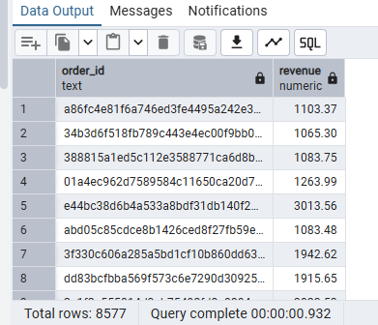

13. Average Order Revenue
Explanation: Finds average revenue per order.

WITH order_revenue AS (
SELECT
order_id,
SUM(payment_value::NUMERIC) AS revenue
FROM olist_order_payments
GROUP BY order_id
)
SELECT AVG(revenue) AS avg_order_value
FROM order_revenue;
OUTPUT:
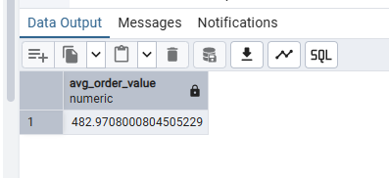
14. CTE + WINDOW
Explanation: Ranks orders based on revenue.

WITH order_revenue AS (
SELECT
order_id,
SUM(payment_value::NUMERIC) AS revenue
FROM olist_order_payments
GROUP BY order_id
)
SELECT
order_id,
revenue,
RANK() OVER (ORDER BY revenue DESC) AS rank
FROM order_revenue;
OUTPUT:

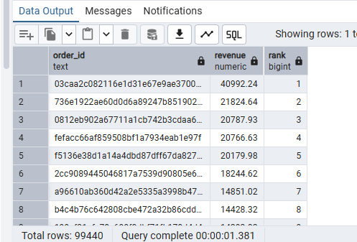
Key Insights :
- Most of the orders are marked as delivered, which shows that the order completion rate is quite good.
- The state SP has the highest number of customers and orders, making it the most active region.
- Credit card is the most commonly used payment method and also brings in the highest revenue.
- A small number of orders contribute a large portion of the total revenue, indicating the presence of high-value purchases.
- Customer spending is not evenly distributed — some customers spend significantly more than others.
Conclusion :
This analysis helped in understanding how customers purchase, how revenue is generated, and how orders are distributed across different regions. By using SQL concepts like grouping, joins, CTEs, and window functions, meaningful insights were extracted from the dataset in a structured way.

